**Punjab University College of Information Technology**

**Computer Networks**



**Assignment #: 1**

**Submitted To: Sir Umair Bilal**

**Submitted By: Tahoor Pirzada**

**BSEF12M522**

**5 Layered Model:**

1. **AppleTalk and the OSI Model**

AppleTalk, Apple Computer, Inc.'s LAN for connecting Macintosh computers, has taken giant strides in the past few years. Originally, connecting Macs so they could share printers was easy. Users plugged a $75 LocalTalk connection box into the Mac's printer port and attached a two-meter cable to the connection box on the next Mac in the network. Each Mac was shipped with the hardware and software required to participate in the network.

However easy the network was to build, users argued that it had major flaws. Its data transfer rate was only 230.4Kbps, and the network could only support 32 Macs. Customers were also required to use shielded twisted pair wiring.

Apple's determination to be taken seriously in the world of business resulted in AppleTalk Phase II, announced in June 1989. AppleTalk Phase II represented a complete turnaround from Apple's usual proprietary stance. It connected LocalTalk, Ethernet and Token Ring networks, supported coaxial cable as well as shielded twisted pair, and supported products that facilitate the integration of Macintoshes into Digital,TCP/IP, UNIX, and OSI environments.

At the Data Link Layer, AppleTalk uses the AppleTalk Link Access Protocol (ALAP). See the AppleTalk and the OSI Model diagram below. Medium access control for bus or star topologies and twisted pair wiring is CSMA/CA (Carrier Sense Multiple Access with Collision Avoidance); CSMA/CD is used for Ethernet, and token passing is used for Token Ring environments. At the Network Layer, the Datagram Delivery Protocol (DDP) supports communication between two sockets, the addressable entities within a node. Address translation is the responsibility of the AppleTalk Address Resolution Protocol (AARP). 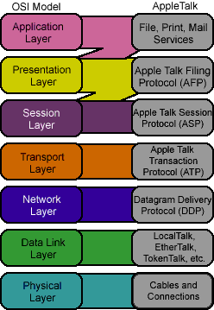

Figure 6-10. AppleTalk and the OSI Model

Four different protocols are supported in the Transport Layer. The Routing Table Maintenance Protocol (RTMP) maintains information about the current configuration of the network. The AppleTalk Echo Protocol (AEP) is used for maintenance. The Name Binding Protocol (NBP) provides translations between character-oriented names and Internet socket addresses. Reliable socket-to-socket transmissions are the responsibility of the AppleTalk Transaction Protocol (ATP).

Four protocols are also supported at the Session Layer. The AppleTalk Session Protocol (ASP) opens, maintains, and closes sessions between sockets. The AppleTalk Data Stream Protocol (ADSP) ensures reliable service between sockets. The Zone Information Protocol (ZIP) maintains a "map" of the zones within the network. The fourth protocol, the Printer Access Protocol (PAP), handles requests for access to Apple LaserWriter printers.

http://www.webclasses.net/demo/intro/5.2/sp/media/app_layer.gifAt the Presentation and Application Layers, the AppleTalk Filing Protocol (AFP) provides access to remote files, and the PostScript protocol supports desktop publishing.

One of the major benefits of AppleTalk networks, dynamic node addressing, continues to be supported in AppleTalk Phase II. This feature assigns node addresses dynamically when the machine is powered on.

**Host Communications Software**

MacDFT (which supports both DFT and CUT mode) lets a Macintosh emulate an IBM 327x terminal to access data on an IBM host running VM/CMS or MVS/TSO. MacAPPC lets Macintosh computers exchange information with other systems supporting IBM's Advanced Program-to-Program Communications (APPC) on a peer-to-peer basis.

The AppleTalk Internet Router lets Macintoshes communicate with systems on an Internet, and MacX25 is available for communications over an X.25 packet switched network. Apple also provides AppleTalk for VMS and MacTCP, programs which developers can use to create Macintosh applications for communication with DEC systems and TCP/IP environments.

1. **IBM PC LANs and the OSI Model**

IBM supports two Network Operating Systems, the PC LAN Program and the OS/2 LAN Server. See the two diagrams below. The PC LAN Program is an enhancement of the earlier PC LAN Support Program, which had been criticized by customers for its poor performance. Recent improvements have resulted in better performance and expanded services.

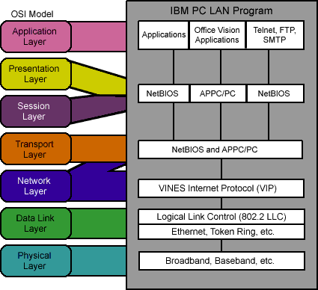

Figure 6-12. IBM PC LAN Program and the OSI Model

While IBM supports the PC LAN Program, the company's clear desire, until recently, has been that customers adopt OS/2 Extended Edition. The strengths of the OS/2 LAN Server reflect that emphasis. However, the announcement in 1991 that IBM would market Novell's NetWare demonstrated continuing market pressure for IBM to support an open environment.

The PC LAN program provides a common support package for all IBM LAN technologies running under PC-DOS, including Token Ring, PC Network (broadband and baseband), and Ethernet. PC LAN Program makes communication among users available through file copy, messaging services, and resource sharing.

PC LAN protocols are concentrated at the Application and Presentation Layers of the OSI Model, including DOS, Redirector, and SMB elements. The NetBIOS driver is the Session Layer interface. The PC LAN Support Program provides support at the Transport and Network Layers, and IEEE 802.3 and IEEE 802.5 are supported at the Data Link Layer.

OS/2 LAN Server extends the functionality of the PC LAN Program to provide complete networking support for OS/2 Extended Edition users. It is in compliance with IBM's guidelines for System Application Architecture (SAA) and supports all IBM LANs and LAN interfaces, including IEEE 802.3, NetBIOS, and LU6.2 (APPC).

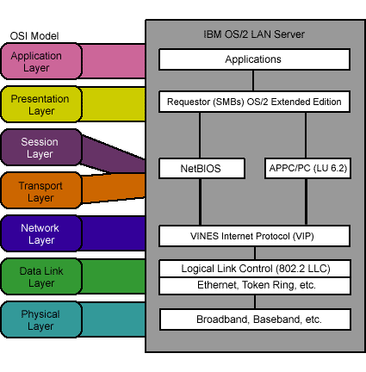

Figure 6-13. OS/2 LAN Server and the OSI Model

At the lower layers, OS/2 LAN Server depends on the PC LAN Program implementation for functionality. NetBIOS support continues at all layers, but support for LU 6.2 (APPC) is added at the Network, Transport, and Session Layers, giving OS/2 LAN Server users access to the SNA world. The Presentation and Application Layers support OS/2 Extended Edition applications.

The key difference between the PC LAN Program and OS/2 LAN Server lies in the latter's support of distributed processing applications. While the PC LAN Program was designed to support stand-alone LANs, although bridges and gateways are supported, OS/2 LAN Server is integrated into IBM's larger networking strategy. IBM is encouraging customers to adopt the company's OS/2 solution as their enterprise-wide PC networking strategy.

IBM provides a number of communications packages for exchange of information with IBM hosts. SNA Host Gateway provides remote connection between the PC network and multiple host applications; the PCs must have PC3270 Emulation Program and an SDLC adapter card installed. And SNA APPC PC lets an application running on a network PC communicate on a peer-to-peer basis with another program on another PC, System/36, or SNA/3270 host over an SDLC link.

1. **Windows NT and the OSI Model**

Microsoft's Windows NT is a 32-bit operating system that was designed to support client applications easily and transparently in a distributed network environment. It includes many of the features and functions of Windows 3.1 plus many enhancements, one of which is networking services. The networking services of Windows NT include support for NetBIOS, NetBEUI, TCP/IP, SPX and IPX protocols.

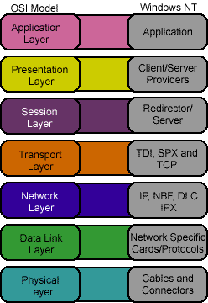

Figure 6-14. Windows NT and the OSI Model

The Windows NT and the OSI Model diagram above shows how Windows NT relates to the OSI reference model. At the Physical and Data Link levels, NT supports various NICs and protocols such as Ethernet and Token Ring. The low-level device drivers that run on the NICs interface with the Network Layer protocols through Network Device Interface Specification, or NDIS. NDIS provides linkage between the Physical Layer protocols and several Network Layer protocols including:

|  |  |
| --- | --- |
| **Protocol** | **Description** |
| NBF | NetBEUI Format |
| DLC | Data Link Control providing mainframe connectivity |
| TCP/IP | Transmission Control Protocol/Internet Protocol |
| IPX | Internet Packet Exchange |

At the Transport Layer, NT supports TCP and SPX. The TDI (Transport Device Interface) layer provides an interface between multiple transport protocols (such as TCP/IP) and multiple networking environments. Redirectors for Windows NT, Novell's NetWare and Banyan's VINES can be loaded simultaneously. The client/server provider allows multiple applications to access the underlying protocol stack.

Windows NT provides support for both client/server applications and peer-to-peer processing through preemptive multitasking, shared and protected memory support. This allows Windows NT to be used in small businesses that do not require large LAN services.

1. **UNIX and the OSI Model**

The UNIX operating system has been around since the early 1970s. It is responsible for managing hardware resources that exist in a computer such as memory, hard disk drives, video output, and CPU processing. It provides programmer capabilities such as editors, compilers, assemblers, and text formatters. The main components of the UNIX operating system are:

|  |  |
| --- | --- |
| http://www.webclasses.net/demo/intro/5.2/sp/units/media/bullet_unitoverview.gif | user processes |
| http://www.webclasses.net/demo/intro/5.2/sp/units/media/bullet_unitoverview.gif | file system |
| http://www.webclasses.net/demo/intro/5.2/sp/units/media/bullet_unitoverview.gif | kernel |
| http://www.webclasses.net/demo/intro/5.2/sp/units/media/bullet_unitoverview.gif | shell |

In addition to these components, UNIX also provides networking capabilities in the base operating system. As with all client/server processes, a UNIX server waits for commands from clients and then executes the commands. UNIX is not usually included when discussing the NOS market because the networking functionality has been built into the operating system for some time.

**Elaborate on why UNIX is not normally considered to be a Network Operating System.**

Networking in UNIX is accomplished using interprocess communications (IPC) between applications and the networking protocol stacks. Most UNIX systems provide multiple protocol suites including TCP/IP, SNA, XNS, and NetBIOS. TCP/IP is normally used as the protocol stack in UNIX networking implementations. The UNIX and the OSI Model diagram below shows a typical UNIX protocol stack.

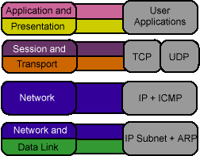

Figure 6-15. UNIX and the OSI Model

Programs are written under UNIX using Application Programming Interfaces (APIs). The three most common UNIX APIs are sockets, Transport Layer Interfaces (TLIs), and streams.

Sockets are general purpose IPC mechanisms used to communicate between a process and a protocol stack or another process. The UNIX socket interface supports both TCP and XNS protocol implementations. The socket interface provides a set of system calls (functions) which networking applications can use to perform networking I/O.

As the name implies, TLI provides an interface to the Transport Layer such as the Transmission Control Protocol (TCP). Applications can use standard TLI function calls to access communication protocol stacks under UNIX.

Streams are another I/O mechanism used under UNIX. Streams are low-level mechanisms used by networking protocol programmers to gain access to lower layers of a protocol stack and for creating protocol software modules.

1. **LANtastic and the OSI Model**

First launched by Artisoft Inc. in 1987, the LANtastic network operating system is now in its sixth version, release 6.0. Artisoft has increased LANtastic's capabilities, complementing its traditional peer-to-peer offering with the option of a more high-end solution; the Universal Client technology whereby networks can be configured as peer-to-peer, dedicated server, or a combination of both.

http://www.webclasses.net/demo/intro/5.2/sp/media/server.gifThe LANtastic system allows the user to choose whether to dedicate a server or to run the server on a user's workstation. By default, the LANtastic NOS sets up every workstation as both server and client; however, on networks with greater than ten nodes, a more common configuration would be to restrict the number of servers to three or four. Typically, these in turn would be divided into file servers (which share their disk resources with other nodes on the network) and print servers. Alternatively, any server can use Artisoft's ALONE program to dedicate resources such as files, storage, disk, and CD-ROM drives, printers, and other peripherals to other computers on the network. In order to provide solutions for communication across multiple hardware and software platforms, Artisoft offers a series of LANtastic Connectivity Solutions. This series includes LANtastic for TCP/IP, LANtastic for Macintosh, and, most recently, LANtastic for OS/2. Other LANtastic strengths include its administration facilities — whereby users have freedom to manage their own workstation's resources and to define access to them. However, there is also the possibility of putting all the administration and management functions in the hands of one person.

**Simply LANtastic**

A streamlined, entry-level version of the LANtastic NOS, it is designed for small and home office networks. It can be easily set up and will allow the sharing of printers, hard drives, and CD-ROM drives. Offices can exchange files between computers and pool network software applications and communicate via e-mail. Security is provided down to subdirectory level for full-access, read-only access, or no access. Simply LANtastic is available in three options that were upgraded in August, 1994 to include parallel port adapters, giving users the additional flexibility of adding a laptop computer to their network. Simply LANtastic Starter Kit — provides two parallel port adapters, software for two PCs, one 25" RG174 cable with 3.5 mm mono phono plugs, two 12" parallel port extender cables, two AC adapters, and documentation.

**Simply LANtastic Add-On Kit**

http://www.webclasses.net/demo/intro/5.2/sp/media/add_on.gifThis kit allows users to add a PC to their network and provides a parallel port adapter, software for one PC, one 25" RG174 cable with 3.5 mm mono phono plugs, one twelve inch parallel port extender cable, AC adapter, and documentation. The addition of an external adapter means that users can simply attach the unit to the outside of their PC, rather than having to open their computers to install a network adapter. Laptop users can interoperate with other users on a 10Mbps Simply LANtastic network. Artisoft also offers starter kits and add-on kits with software-configurable internal adapters. Both the parallel port adapters and the internal adapters can be used together on the same network.

**LANtastic Z Kit**

This system is designed to give home PC users modem access to the files, programs, and printers connected to an office PC. It can also be applied to set up a PC-to-PC file transfer system. LANtastic Z creates a network by connection of any combination of two IBM-compatible laptops, notebooks, and desktops using serial cable, parallel cable, or modem. When used in conjunction with LANtastic Interchange, LANtastic Z can create a wide-area network between two LANtastic sites. The LANtastic Z kit includes a 25" serial cable and an 18" parallel cable.

**LANtastic 6.0**

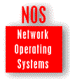Artisoft considers this latest upgrade to its established peer-to-peer NOS to be the most significant, since it brings LANtastic into line with the growing trend away from purely peer-to-peer NOSs and towards the new, more scaleable Universal Client NOS for small — to medium-sized businesses. The universal client technology provides seamless connectivity to network servers of Novell Inc., Microsoft Corp., and IBM Corp. Additions for Version 6.0 include an integrated groupware system, providing advanced e-mail, network scheduling, faxing, and paging features. It also provides improved network performance and enhanced network management capabilities. LANtastic does not require a dedicated server and allows any PC on the network to act as a server, workstation, or both. It supports up to 500 users per server in both DOS and Windows environments and provides a choice of a DOS character-based or graphical Windows menu systems. DOS and Windows workstations can be freely mixed, either as clients or servers.

**Universal Client Technology**

This feature includes NetWare Core Protocol (NCP) support allowing LANtastic 6.0 workstations to access NetWare servers for file and print services. It also means that users can operate both types of networks transparently in the same LAN while adding flexible networking features to departmental workgroups in an existing NetWare installation. Artisoft and Novell have also entered into an agreement that includes Novell certification of the interoperability between LANtastic network clients and NetWare servers. The intention is to get the official certification for the LANtastic 6.0 network in the near future. Through Server Message Block (SMB) client support, LANtastic 6.0 workstations gain the capability to access any SMB-based server for file and print services. This support means that LANtastic 6.0 network users are provided with access to servers running Microsoft Windows NT and Windows for Workgroups, IBM LAN Server, and any other system that is SMB Version 1.0 compatible.

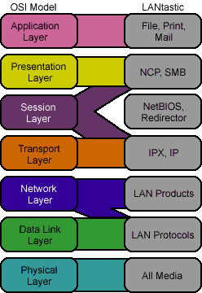

Figure 6-16. LANtastic and the OSI Model